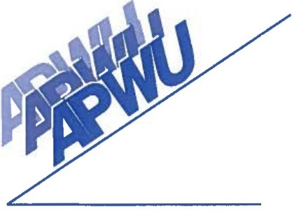
Palm Beach Area Local, No. 749
American Postal Workers Union, AFL-CIO

1957 10th Avenue North • Lake Worth, Florida 33461 • (561) 588-8572 • Fax (561) 588-4504

EXECUTIVE BOARD 1/2021-12/2023

PRESIDENT John Kevin Young 561-312-8599
kevinapwu@outlook.com

VICE PRESIDENT Stephen Waszak 561-308-5454
Steveapwu@outlook.com

SECRETARY/TREASURER Christina Berrios 561-308-3400
berriosapwu@live.com

CLERK CRAFT DIRECTOR Gary Leonard 561-502-3443
garyleonard53@aol.com

MAINTENANCE CRAFT Jim Cook 561-478-9115
DIRECTOR JamesCook4U@comcast.net

MVS/SPECIAL DELIVERY Glenn Wulff 561-307-8604
DIRECTOR glenn1963@hotmail.com

EXECUTIVE COUNCIL 1/2021-12/2023

DIRECTOR OF INDUSTRIAL Conard “Robbie” Robinson 561-603-8305
RELATIONS ConardRobinson@yahoo.com

HUMAN RELATIONS Chantillee Townsend 561-588-8572 CTownsend.APWU@outlook.com
DIRECTOR
LEGISLATIVE DIRECTOR C Ann Milton 561-588-8572
Cann.Milton@usps.gov

TRUSTEE VACANT

TRUSTEE Karin Nolf 561-588-8572
Karin.I.Nolf@usps.gov

TRUSTEE Richard Cascone 561-317-0576
Cascone.Richard@icloud.com

ASSOCIATE OFFICE VACANT
DIRECTOR – SOUTH

ASSOCIATE OFFICE Greg Watts 561-588-8572
DIRECTOR – NORTH mrwatts@comcast.net

® 2

