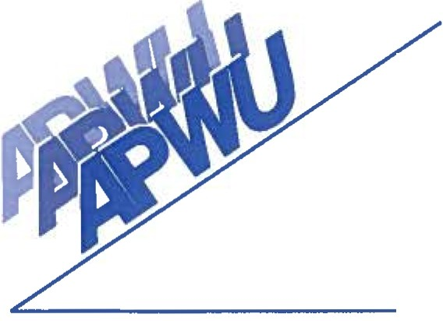
Palm Beach Area Local, No. 749
American Postal Workers Union, AFL-CIO

1957 10th Avenue North • Lake Worth, Florida 33461 • (561) 588-8572 • Fax (561) 588-4504

EXECUTIVE BOARD
1/2015-12/2017

PRESIDENT Gary Hamrick 561-779-2266
hamrickapwu@live.com

VICE PRESIDENT Rhonda Cartrett 561-248-6253
rhondaapwu@live.com

SECRETARY/TREASURER Christina Berrios 561-308-3400
berriosapwu@live.com

CLERK CRAFT DIRECTOR Gary Leonard 561-502-3443
garyleonard53@aol.com

MAINTENANCE CRAFT Rob Linnus 561-478-9115
DIRECTOR

MVS/SPECIAL DELIVERY Vacant
DIRECTOR

EXECUTIVE COUNCIL
1/2015-12/2017

DIRECTOR OF INDUSTRIAL Matt MacDonnell 561-478-9115
RELATIONS

HUMAN RELATIONS Vacant

DIRECTOR
LEGISLATIVE DIRECTOR Conard Robinson 561-568-3052
“Robbie” conardrobinson@yahoo.com

TRUSTEE Vacant

TRUSTEE Vacant

TRUSTEE Vacant

ASSOCIATE OFFICE Vacant
DIRECTOR – SOUTH

ASSOCIATE OFFICE Vacant
DIRECTOR - NORTH

® 2

